Exercise 13- Creating Views
- What are three uses for a view from a DBA’s perspective?
- Security – A view can restrict access to specific columns/rows while hiding sensitive data
- Simplification – A view simplifies complex queries by storing them as reusable objects
- Data Abstraction – A view provides a layer of abstraction so users don’t directly interact with underlying tables
- Create a simple view called view_d_songs that contains the ID, title and artist from the DJs on Demand table for each “New Age” type code. In the subquery, use the alias “Song Title” for the title column.
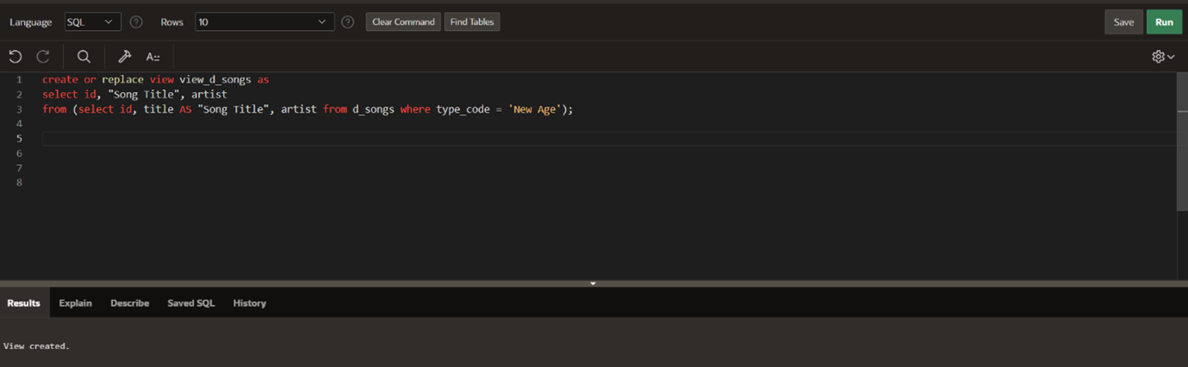
- SELECT * FROM view_d_songs. What was returned?
- It will return all rows from view_d_songs view
- Specifically onlt the songs where typr_code = ‘new Age’
- REPLACE view_d_songs. Add type_code to the column list. Use aliases for all columns. Or use alias after the CREATE statement as shown.
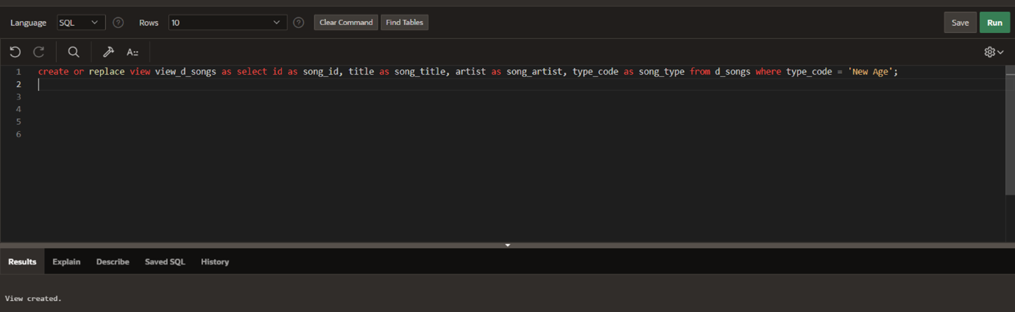
- Jason Tsang, the disk jockey for DJs on Demand, needs a list of the past events and those planned for the coming months so he can make arrangements for each event’s equipment setup. As the company manager, you do not want him to have access to the price that clients paid for their events. Create a view for Jason to use that displays the name of the event, the event date, and the theme description. Use aliases for each column name.
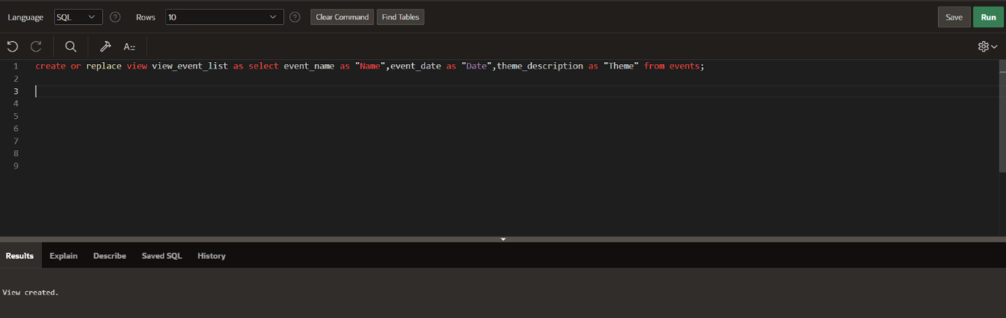
- It is company policy that only upper-level management be allowed access to individual employee salaries. The department managers, however, need to know the minimum, maximum, and average salaries, grouped by department. Use the Oracle database to prepare a view that displays the needed information for department managers.
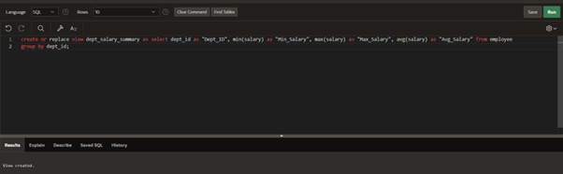

DML operations and views:
Use the DESCRIBE statement to verify that you have tables named copy_d_songs, copy_d_events, copy_d_cds, and copy_d_clients in your schema. If you don’t, write a query to create a copy of each.
1. Query the data dictionary USER_UPDATABLE_COLUMNS to make sure the columns in the base tables will allow UPDATE, INSERT, or DELETE. All table names in the data dictionary are stored in uppercase.
Use the same syntax but change table_name of the other tables.
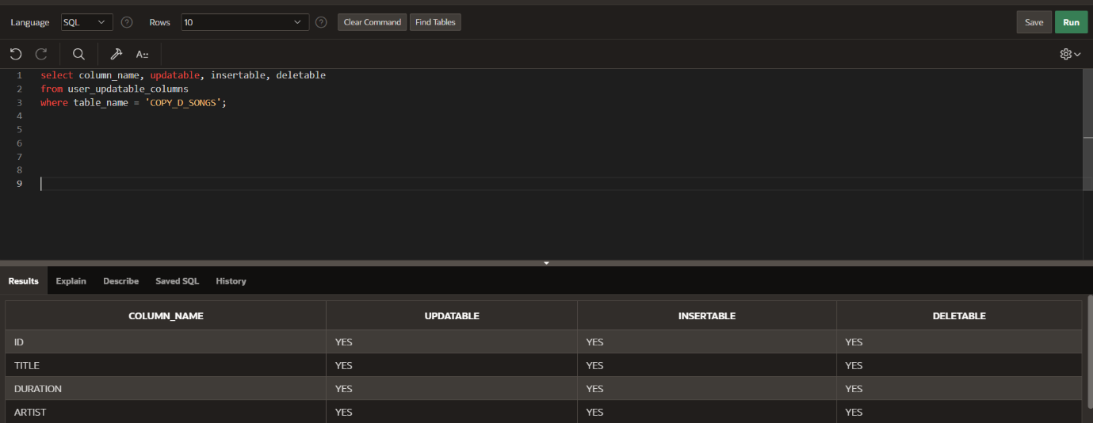
2. Use the CREATE or REPLACE option to create a view of all the columns in the copy_d_songs table called view_copy_d_songs.
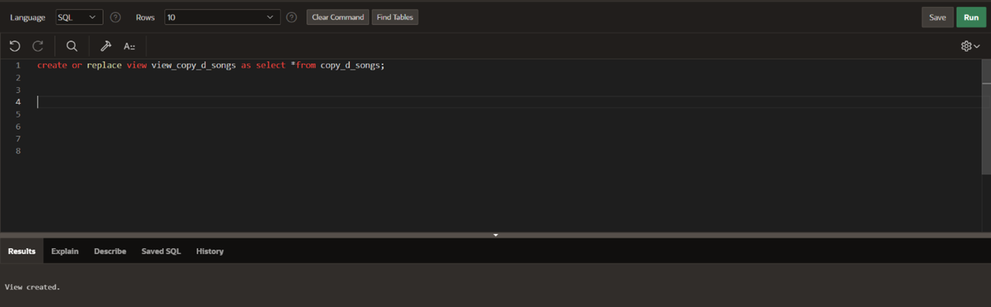
3. Use view_copy_d_songs to INSERT the following data into the underlying copy_d_songs table. Execute a SELECT * from copy_d_songs to verify your DML command. See the graphic.
ID TITLE DURATION ARTIST TYPE_CODE
88 Mello Jello 2 The What 4
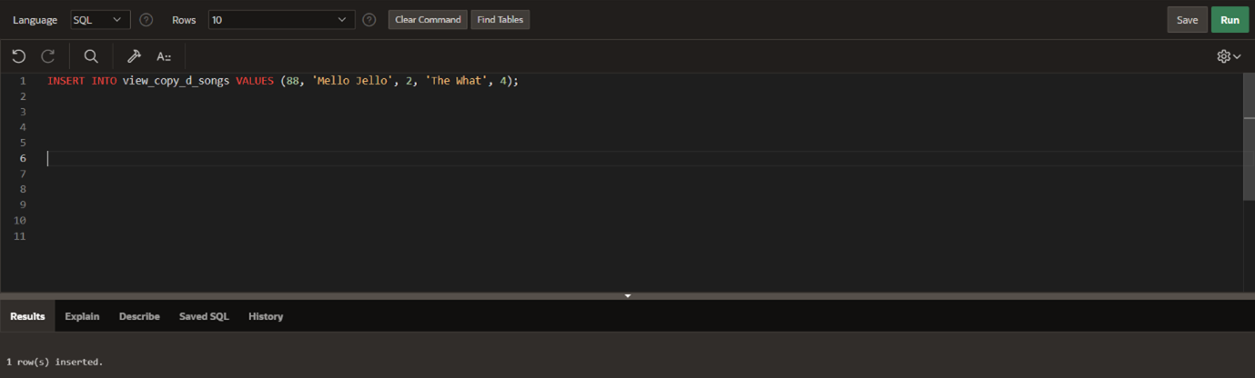
4. Create a view based on the DJs on Demand COPY_D_CDS table. Name the view read_copy_d_cds. Select all columns to be included in the view. Add a WHERE clause to restrict the year to 2000. Add the WITH READ ONLY option.
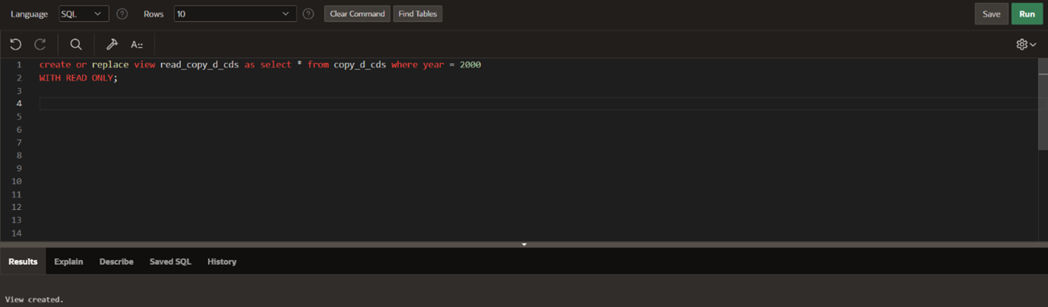
5. Using the read_copy_d_cds view, execute a DELETE FROM read_copy_d_cds WHERE cd_number =90.
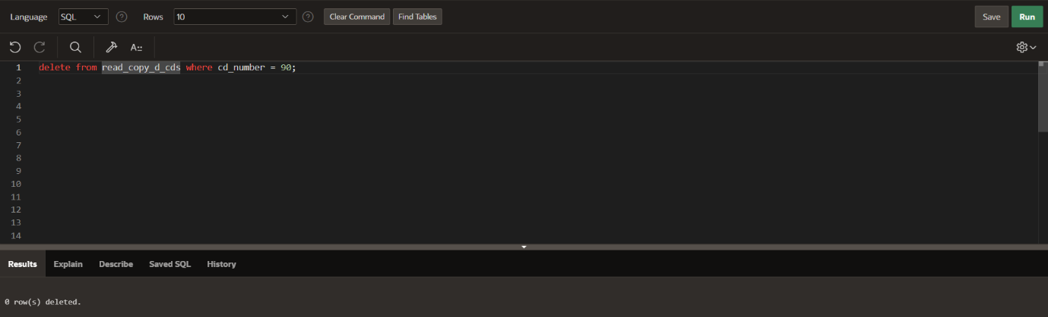
6. Use REPLACE to modify read_copy_d_cds. Replace the READ ONLY option with WITH CHECK OPTION CONSTRAINT ck_read_copy_d_cds. Execute a SELECT * statement to verify that the view exists.
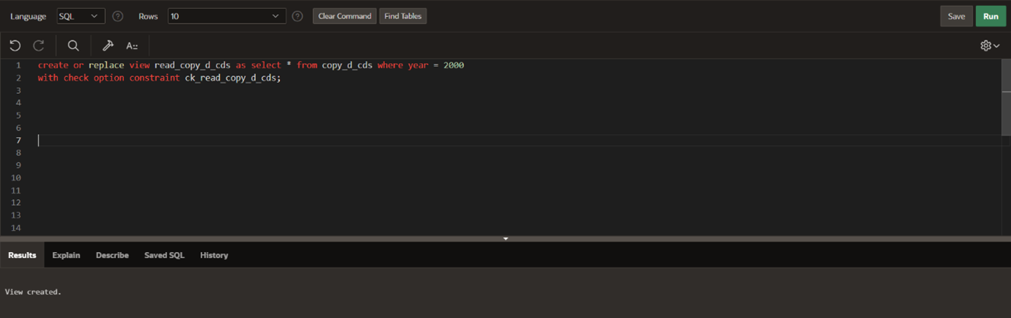
7. Use the read_copy_d_cds view to delete any CD of year 2000 from the underlying copy_d_cds.
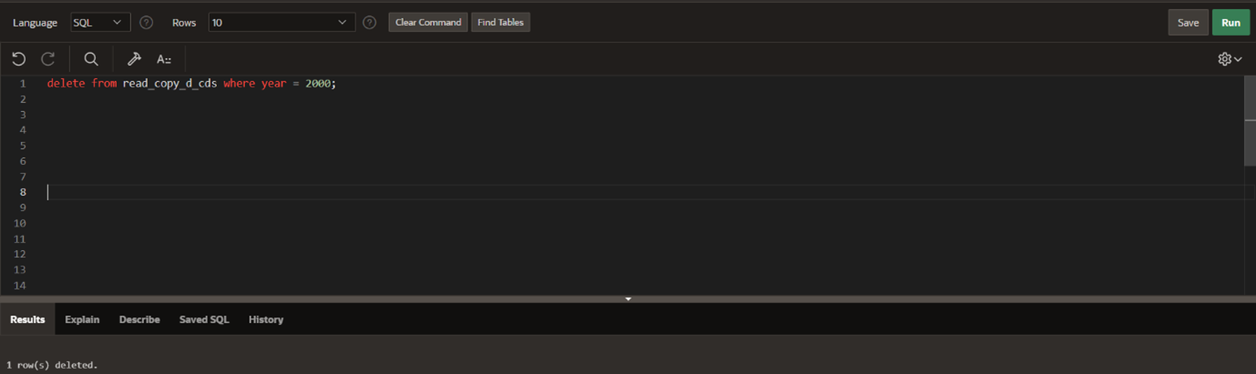
8. Use the read_copy_d_cds view to delete cd_number 90 from the underlying copy_d_cds table.
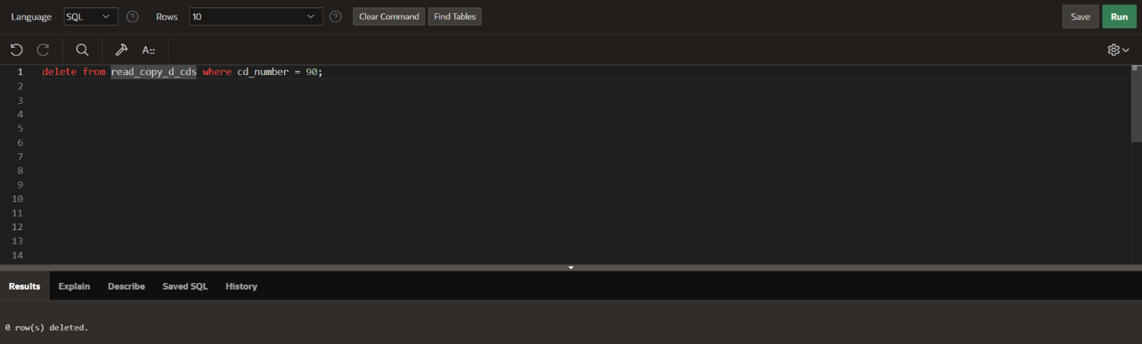
9. Use the read_copy_d_cds view to delete year 2001 records.
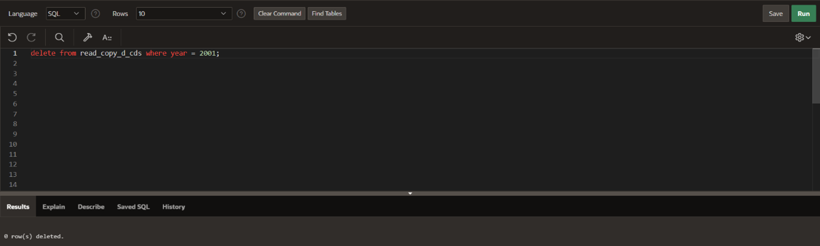
10. Execute a SELECT * statement for the base table copy_d_cds. What rows were deleted?
* After executing select*from copy_d_cds the rows that matched the earlier delete condition are missing.
11.What are the restrictions on modifying data through a view?
* Data can be modified through a view only if it is based on a single table and does not contain joins, aggregates or group by.
12. What is Moore’s Law? Do you consider that it will continue to apply indefinitely? Support your opinion with research from the internet.
* Moore’s law states that the number of transistors on a chip doubles every 2 years. It is slowing down due to physical limits, so it cannot continue indefinitely.
13. What is the “singularity” in terms of computing?
* The singularity is a point where ai surpasses human intelligence. It may lead to rapid, uncontrollable technological growth.

Managing Views:
1. Create a view from the copy_d_songs table called view_copy_d_songs that includes only the title and artist. Execute a SELECT * statement to verify that the view exists.
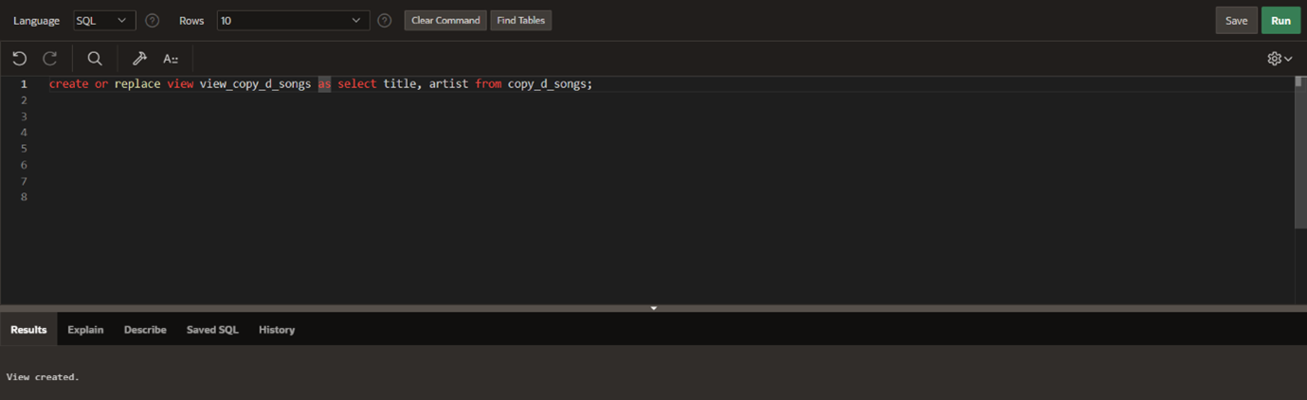
2. Issue a DROP view_copy_d_songs. Execute a SELECT * statement to verify that the view has been deleted.
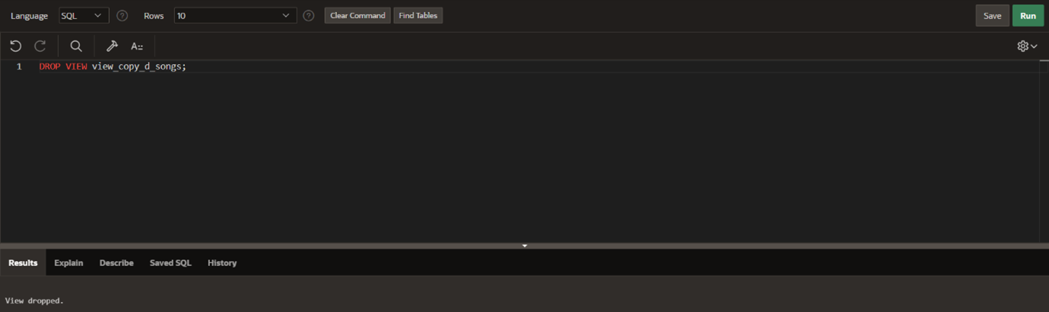
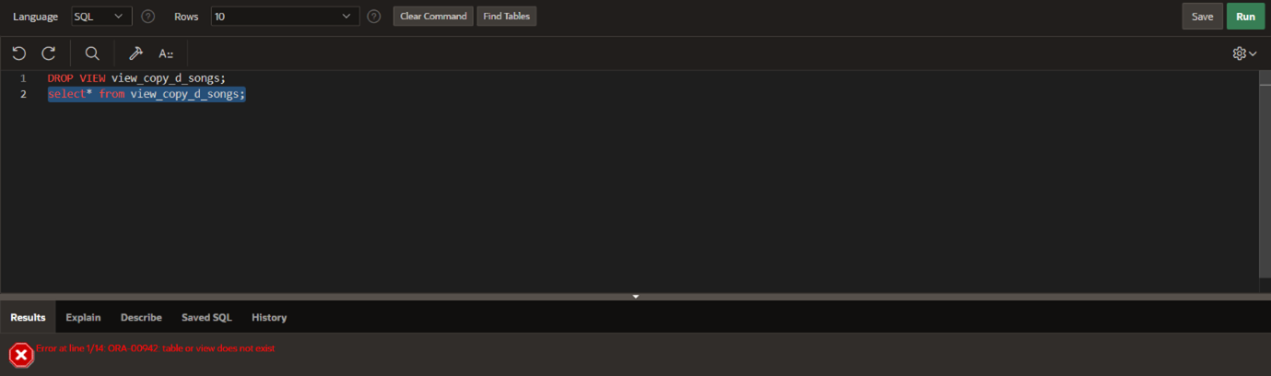
3. Create a query that selects the last name and salary from the Oracle database. Rank the salaries from highest to lowest for the top three employees.
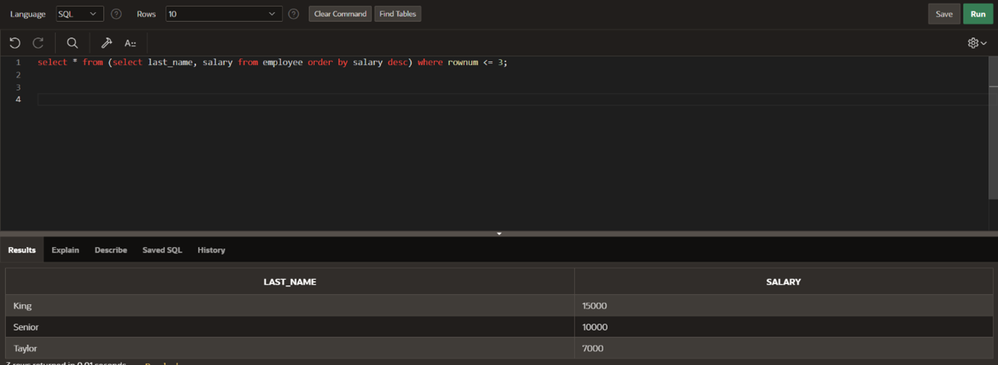
4. Construct an inline view from the Oracle database that lists the last name, salary, department ID, and maximum salary for each department. Hint: One query will need to calculate maximum salary by department ID.
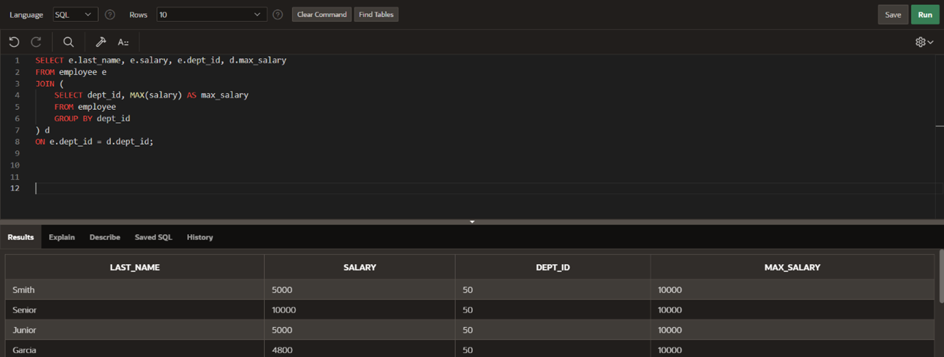
5. Create a query that will return the staff members of Global Fast Foods ranked by salary from lowest to highest.
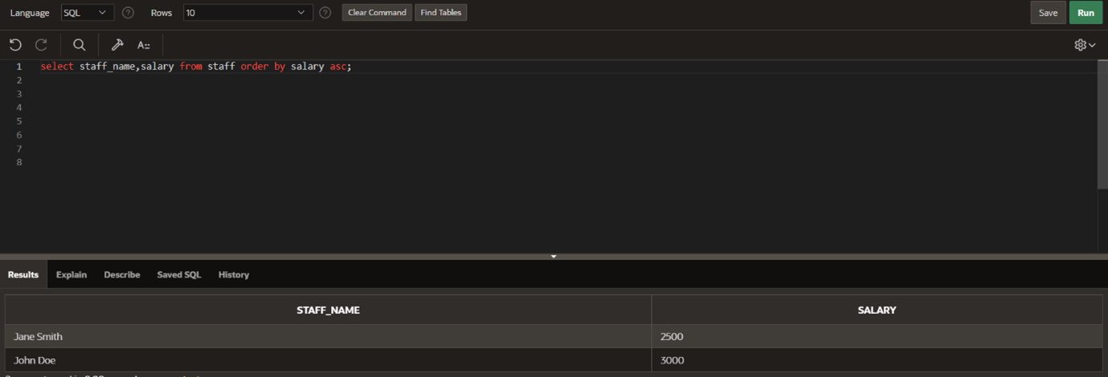

Indexes and Synonyms:
1. What is an index and what is it used for?
An index is a database object that improves the speed of data retrival. It is used to quickly locate rows without scanning the entire table.
2. What is a ROWID, and how is it used?
ROWID is a unique address for each row in a table. It is used to quickly access a row’s exact location in database.
3. When will an index be created automatically?
An index is created automatically when a primary key or unique constraint is defined on a table column.
4. Create a nonunique index (foreign key) for the DJs on Demand column (cd_number) in the D_TRACK_LISTINGS table. Use the Oracle Application Express SQL Workshop Data Browser to confirm that the index was created.
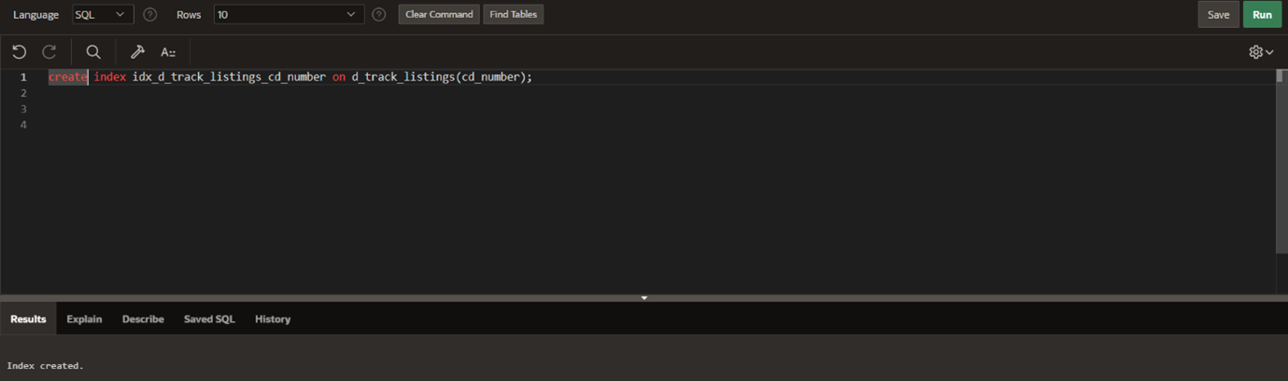
5. Use the join statement to display the indexes and uniqueness that exist in the data dictionary for the DJs on Demand D_SONGS table.
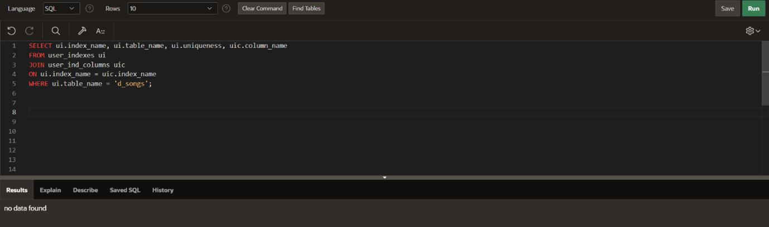
6. Use a SELECT statement to display the index_name, table_name, and uniqueness from the data dictionary USER_INDEXES for the DJs on Demand D_EVENTS table.
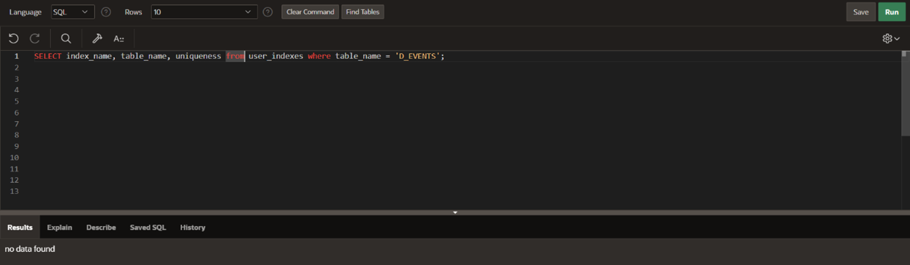
7. Write a query to create a synonym called dj_tracks for the DJs on Demand d_track_listings table.
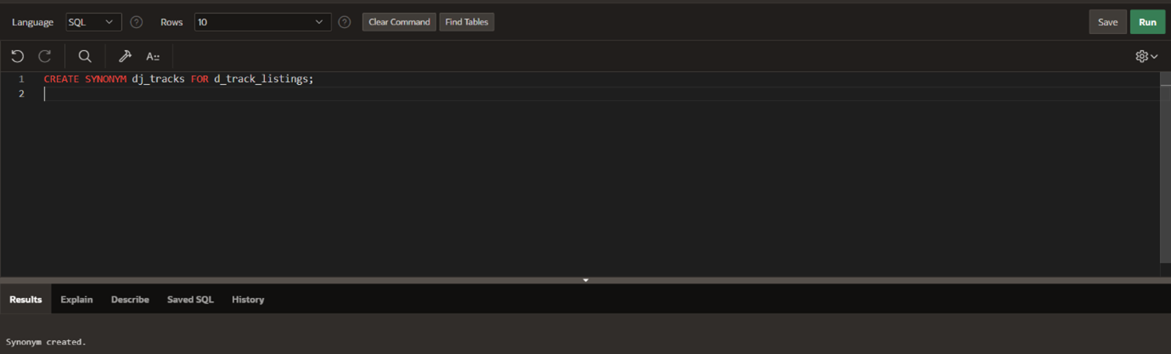
8. Create a function-based index for the last_name column in DJs on Demand D_PARTNERS table
that makes it possible not to have to capitalize the table name for searches. Write a SELECT statement that would use this index.
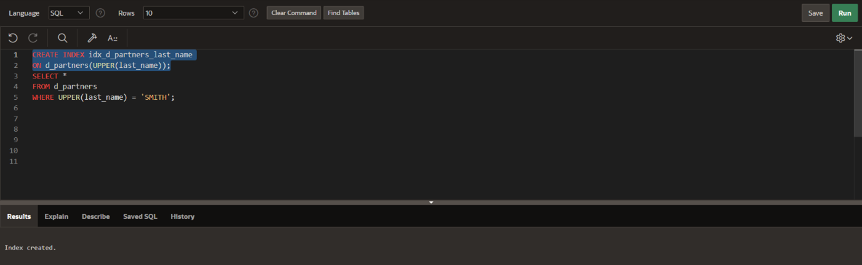
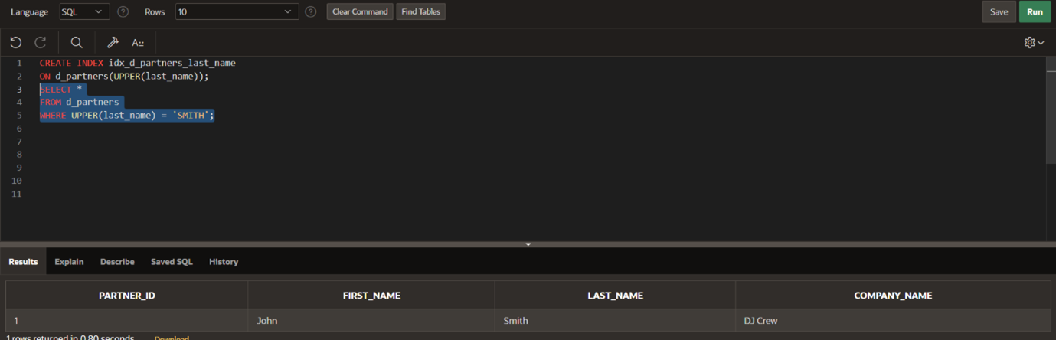

9. Create a synonym for the D_TRACK_LISTINGS table. Confirm that it has been created by querying the data dictionary.
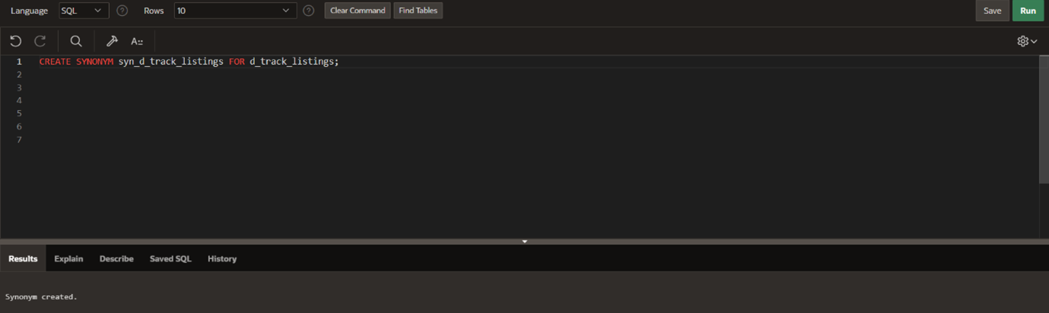
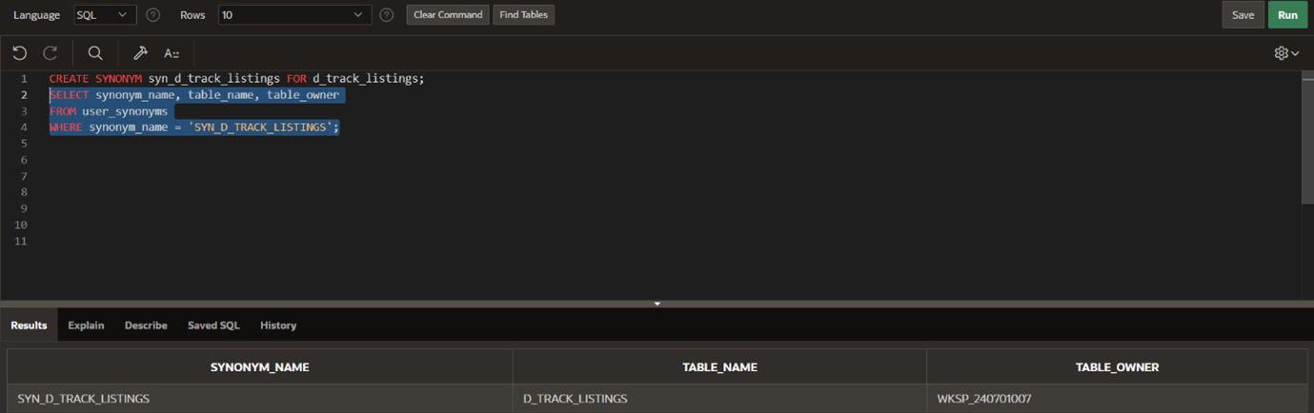
10.Drop the synonym that you created in question
